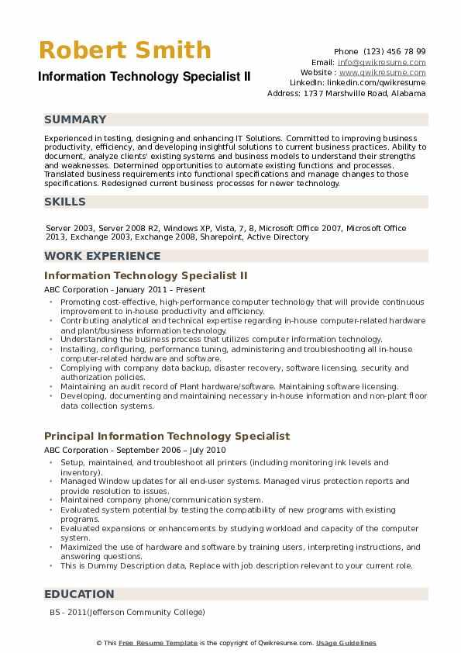
Robert Smith
Information Technology Specialist II
Phone (123) 456 78 99
Email: info@qwikresume.com
Website: www.qwikresume.com Linkedin: linkedin.com/qwikresume Address: 1737 Marshville Road, Alabama
SUMMARY
Experienced in testing, designing and enhancing IT Solutions. Committed to improving business productivity, efficiency, and developing insightful solutions to current business practices. Ability to document, analyze clients' existing systems and business models to understand their strengths and weaknesses. Determined opportunities to automate existing functions and processes. Translated business requirements into functional specifications and manage changes to those specifications. Redesigned current business processes for newer technology.
SKILLS
Server 2003, Server 2008 R2, Windows XP, Vista, 7, 8, Microsoft Office 2007, Microsoft Office 2013, Exchange 2003, Exchange 2008, Sharepoint, Active Directory
WORK EXPERIENCE
Information Technology Specialist II
ABC Corporation - January 2011 - Present
• Promoting cost-effective, high-performance computer technology that will provide continuous improvement to in-house productivity and efficiency.
⚫ Contributing analytical and technical expertise regarding in-house computer-related hardware and plant/business information technology.
⚫ Understanding the business process that utilizes computer information technology.
⚫ Installing, configuring, performance tuning, administering and troubleshooting all in-house computer-related hardware and software.
⚫ Complying with company data backup, disaster recovery, software licensing, security and authorization policies.
• Maintaining an audit record of Plant hardware/software. Maintaining software licensing.
• Developing, documenting and maintaining necessary in-house information and non-plant floor data collection systems.
Principal Information Technology Specialist
ABC Corporation - September 2006 - July 2010
⚫ Setup, maintained, and troubleshoot all printers (including monitoring ink levels and Inventory).
⚫ Managed Window updates for all end-user systems. Managed virus protection reports and provide resolution to issues.
Maintained company phone/communication system.
Evaluated system potential by testing the compatibility of new programs with existing
programs.
Evaluated expansions or enhancements by studying workload and capacity of the computer
system.
⚫ Maximized the use of hardware and software by training users, interpreting instructions, and answering questions.
⚫This is Dummy Description data, Replace with job description relevant to your current role.
EDUCATION
BS-2011(Jefferson Community College)
© This Free Resume Template is the copyright of Qwikresume.com. Usage Guidelines

